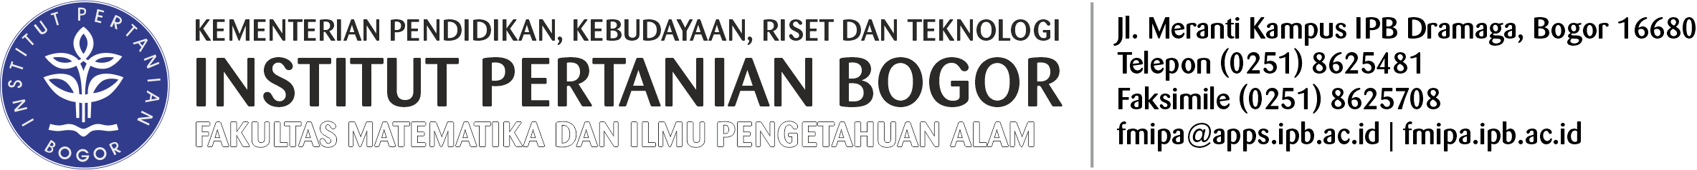

FORMULIR SURAT KETERANGAN LULUS
Nama Lengkap : ……………………………………………………………………………….
NIM : ……………………………………………
Tempat dan Tgl. Lahir : ……………………………………………………………………………….
Program Studi : …………………………………………………….…………………………
Program/Strata : ……………………………………………
Sponsor (Biaya) : ……………………………………………………………………………….
Tgl. Ujian Tesis/Promosi : ……………………………………………………………………………….
Tgl. Penyerahan Tesis/Disertasi : ………………………………………………………………………
Alamat Rumah : ……………………………………………………………………………….
……………………………………………………………………………….
……………………………………………………………………………….
No. Telp.…………………………………/HP….…………………………
Judul Tesis/Disertasi : ……………………………………………………………………………….
……………………………………………………………………………….
……………………………………………………………………………….
……………………………………………………………………………….
Bogor,………….………..……………
Pemohon

…………………………………………
Catatan:
- Lampirkan Fotokopi Ijazah Sebelumnya
- Lampirkan Progress Naskah Jurnal
- Lampirkan Fotokopi Lembar Pengesahan Tesis/Disertasi

